**12.1 Fundamental Concepts of Genetics\***

* Chromosomes contain genes in a linear sequence
* Alleles are alternative forms of a gene
  + Dominant or recessive
* Genotype = combination of alleles one has at a given genetic locus
* Phenotype = observable manifestation of a genotype

Patterns of Dominance

1. Complete dominance
   1. One dominant allele and one recessive allele
2. Codominance
   1. More than one dominant allele
3. Incomplete dominance
   1. No dominant allele; heterozygotes have **intermediate** phenotypes

Penetrance and Expressivity

* Penetrance = the proportion of a population with a given genotype who express the phenotype
  + E.g. individuals with over 40 sequence repeats have full penetrance → 100% of individuals with this allele show symptoms of Huntington’s disease
* Expressivity = varying phenotypic manifestations of a given genotype

Mendelian Concepts

1. Mendel’s first law (of segregation)
   1. An organism has two alleles for each gene, which segregate during meiosis, resulting in gametes carrying only one allele for a trait
2. Mendel’s second law (of independent assortment)
   1. The inheritance of one allele does not influence the probability of inheriting a given allele for a different trait

DNA as Genetic Material

1. Griffith experiment
   1. Demonstrated the transforming principle → converting non-virulent bacteria into virulent bacteria by exposure to heat-killed virulent bacteria
2. Avery-MacLeod-McCarty experiment
   1. Demonstrated that DNA is the genetic material
   2. Degradation of DNA led to a cessation of bacterial transformation
3. Hershey-Chase experiment
   1. Confirmed that DNA is the genetic material
   2. Only radiolabeled DNA could be found in bacteriophage-infected bacteria

**12.2 Changes in the Gene Pool\***

Mutations

1. Nucleotide mutation
   1. Point mutations (the substitution of one nucleotide for another)
      1. Silent → no effect on the protein
      2. Missense → results in the substitution of one amino acid for another
      3. Nonsense → results in the substitution of a **stop codon** for an amino acid
   2. Frameshift mutations (moving the three-letter transcriptional reading frame)
      1. Insertion
      2. Deletion
2. Chromosomal mutation
   1. Deletion mutations → a large segment of DNA is lost
   2. Duplication mutations → a segment of DNA is copied multiple times
   3. Inversion mutations → a segment of DNA is reversed
   4. Insertion mutations → a segment of DNA is **moved** from one chromosome to another
   5. Translocation mutations → a segment of DNA is **swapped** with a segment of DNA from another chromosome

Leakage

* A flow of genes between species through hybrid offspring e.g. *beefalo*

Genetic Drift

* Occurs when the composition of a gene pool changes as a result of chance
  + More pronounced in small populations
  + Founder effect = extreme case of genetic drift
    - Due to bottlenecks that drastically and suddenly reduce the size of the population e.g. natural barriers, catastrophic events
    - Leads to inbreeding → increased prevalence of certain homozygous phenotypes

**12.3 Analytical Approaches in Genetics\***

Punnett Squares

1. Monohybrid cross → accounts for one gene
2. Dihybrid cross → accounts for two genes
3. Sex-linked cross → sex chromosomes are used to indicate sex as well as genotype

* Test cross (or back cross): always cross back with **homozygous recessive** → helps to determine unknown genotype

Gene Mapping

* Recombination frequency (θ) is the likelihood of two alleles being separated during crossing over in meiosis

Hardy-Weinberg Principle

* 5 conditions for **Hardy-Weinberg equilibrium** → population is not undergoing evolution → allele frequencies will remain stable over time
  + The population is very large (no genetic drift)
  + There are no mutations that affect the gene pool
  + Mating between individuals in the population is random (no sexual selection)
  + There is no migration of individuals into or out of the population
  + The genes in the population are all equally successful at reproducing
* **Equation**

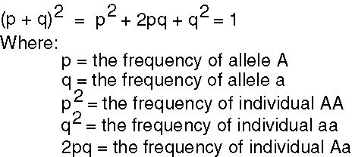

**12.4 Evolution\***

Natural Selection

* States that chance variations exist between individuals
* Advantageous variations - those that increase an individual’s fitness for the environment - afford the most opportunity for reproductive success
* The theory applies to a **population of organisms, not to a particular individual**

Modern synthesis model (neo-Darwinism)

* Accounts for mutation and recombination as mechanisms of variation
* Considers **differential reproduction** to be the mechanism of reproductive success
  + This means that the change that is more favourable to the organism’s reproductive success is more likely to be passed on to the next generation
* Focuses on **inclusive fitness** instead of individual fitness
  + Considers an organism’s success to be based on the number of offspring, success in supporting offspring, and the ability of the offspring to then support others
  + Survival of offspring or relatives ensures continuation of genes in subsequent generations

Punctuated equilibrium

* Considers evolution to be a very slow process with intermittent rapid bursts of evolutionary activity

Types of selections → changes in phenotypes

1. Stabilizing selection
2. Directional selection
3. Disruptive selection → can lead to speciation
   1. Adaptive radiation = rapid emergence of multiple species from a common ancestor, each of which occupies its own ecological niche

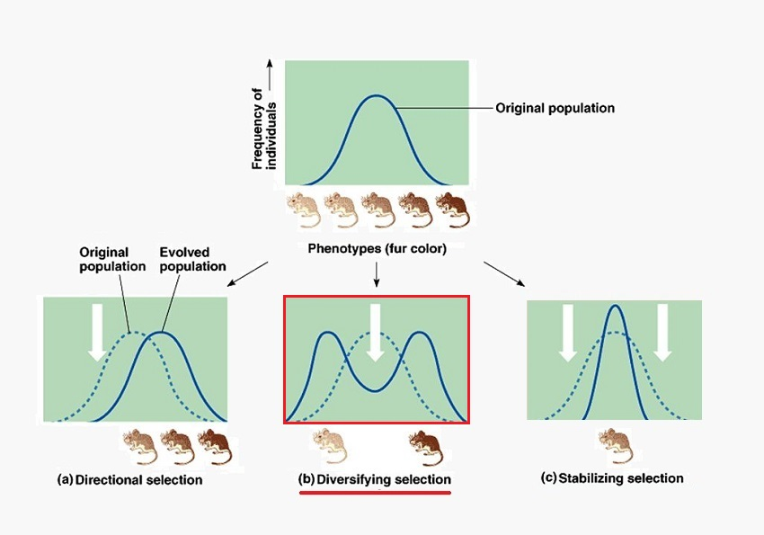

Speciation

* Speciation = the formation of a new species through evolution
* Species = the largest group of organisms capable of breeding to form fertile offspring
* Species are reproductively isolated from each other
  + Prezygotic mechanisms → prevent formation of zygote completely
    - Temporal isolation (breeding at different times)
    - Ecological isolation (living in different niches within the same territory)
    - Behavioural isolation (a lack of attraction between members of the two species due to differences in pheromones, courtship displays, etc)
    - Reproductive isolation (incompatibility of reproductive anatomy)
    - Gametic isolation (intercourse can occur, but fertilization cannot)
  + Postzygotic mechanisms → allow for gamete fusion but yield either nonviable or sterile offspring
    - Hybrid inviability (formation of a zygote that cannot develop to term)
    - Hybrid sterility (forming hybrid offspring that cannot reproduce)
    - Hybrid breakdown (forming first-generation hybrid offspring that are viable and fertile, but second-generation hybrid offspring that are inviable or infertile)
* Two species can evolve with different relationship patterns
  + Divergent evolution
    - Occurs when **two species sharing a common ancestor** become **more different**
  + Parallel evolution
    - Occurs when **two species sharing a common ancestor** evolve in **similar ways due to analogous selection pressures**
  + Convergent evolution
    - Occurs when **two species not sharing a recent ancestor** evolve to become **more similar to analogous selection pressures**

Measuring Evolutionary Time

* Molecular clock model: The degree of difference in the genome between two species is related to the amount of time since the two species broke off from a common ancestor